COSCAP  South Asia | Cooperative Development of Operational Safety & | 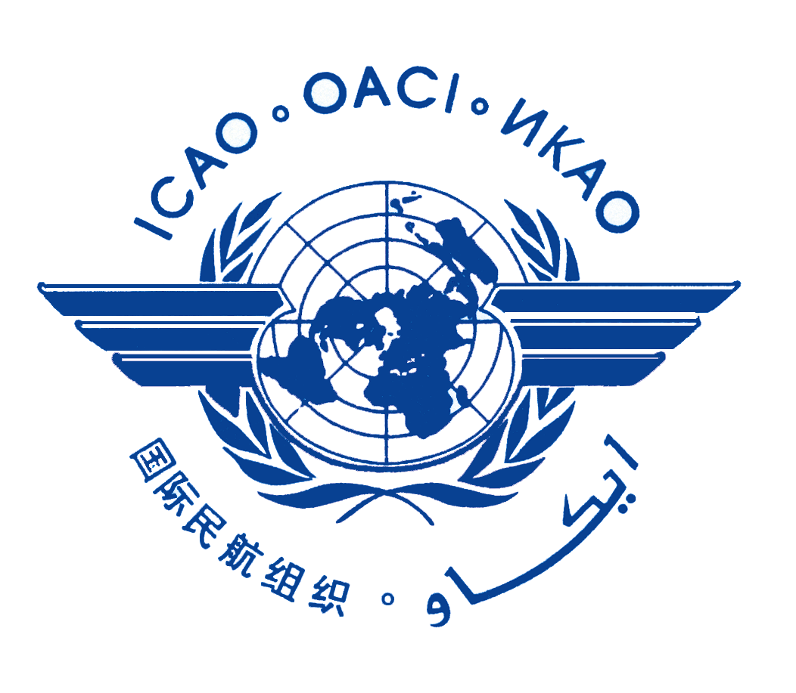
 | Continuing Airworthiness Programme
28th COSCAP-SA STEERING COMMITTEE MEETING

Regional Aviation Safety Teams (RASTs)
Reports and Proposed Actions
Discussion Paper 3 (DP-3)

(Presented by CTA)

SUMMARY
The purpose of this paper is to present to the Steering Committee the conclusions and proposed actions from the 22th SARAST meeting. The 2020 Record of Conclusions arising from this meeting is located in Appendix III.

1 Background

1.1 The objective of the SARAST is to recommend accident prevention interventions to the Steering Committee. The recommendations, once approved by the Steering Committee, may be implemented through the coordinated efforts of the regulatory authorities, in consonance with service providers, airlines and aircraft manufacturers. When such actions are endorsed by the Steering Committee, the Team Members will serve as focal points for introducing the interventions within their respective Administrations and for coordinating their government's efforts with industry.
1.2 To accomplish the objectives, the team will undertake its deliberations in full consideration of the work of the RASG / APRAST. The priority for the Team will be to introduce, support, and develop actions which have the potential to effectively reduce regional aviation risks to enhance aviation safety.
1.3 Since the 27th Meeting of the Steering Committee, the APRAST has completed 2 meetings, of which one of them was conducted virtually. The 14th APRAST meeting was held on May 20-24, 2019 in Bangkok and the 15th APRAST meeting was held virtually on June 24-25, 2020.
1.4 Although the ICAO Regional Office acts as Secretariat for the RASG / APRAST, the CTA COSCAP SA is actively engaged in discussions for activities established under the APRAST.
1.5 For information, a copy of the Report of the 15th Meeting of the Asia Pacific Regional Aviation Safety Team (APRAST) can be found at: https://www.icao.int/APAC/Meetings/Pages/2020-APRAST15.aspx
1.6 The 21st SARAST meeting took place on November 21-22, 2019 in Bangkok, Thailand. The Record of Conclusion may be found in Appendix IV.
1.7 The most recent SARAST - 22st SARAST meeting took place on October 28-29, 2020 virtually using ZOOM as a platform. The Record of Conclusion can be found in Appendix III.
2 Discussion
2.1 All Member States attended the 22nd SARAST meeting. The meeting involved the following key activities and highlights:
2.2.1 Three key activities of the 22th SARAST involved the following:
- Review and discussion of each Member State status towards the development and implementation of APRAST SEI Safety Tools:
- Member State’s progress on the implementation of the Safety Tools is tracked on the “COSCAP SA Safety Tool Tracker”. The tracker identifies which States and area(s) that require support from the COSCAP SA office.
- Member States are progressing very well on the development and implementation of the APRAST Safety Tools. A copy of each member State progress on the APRAST Safety Tools can be found in Appendix II.
- Review and discussion of each Member State - National Aviation Safety Team (NAST) safety issues:
- In addition to sharing national safety issues, one of the key objectives was to identify areas of safety concerns that were common among Member States.
- Unfortunately, due to the COVID pandemic, many States did not have an opportunity to hold a NAST meeting in 2020 due to other priorities. Nonetheless, Member states presented their key safety issues and also their COVID aviation related experiences.
- Details of each Member State safety issues and COVID experiences may be found in Appendix III – Record of Conclusions.
2.2.2 Other Highlights of SARAST discussions included the following:
- English Language Examinations: During the 2019 RASG, a presentation was made on the irregularities and inconsistencies of the application of English language examinations. Since this problem is still prominent, COSCAP SA will provide workshops/seminars in 2021 in order to standardize the examination procedures and application
- Recruitment and retention of inspectors – still a big problem within South Asia. In order to share best practices and develop potential solutions in recruitment and retention (R&R) of inspectors, it was proposed to hold an R&R workshop in 2021 accordingly. A Discussion Paper (DP) would then be developed and presented to the 29th SCM in 2022.
- APAC ICAO Monitoring Tool: States are also to update their APRAST SEI Safety Tool progress on the APAC ICAO Monitoring Tool.
- Reporting of Runway Conditions and UPRT: Timely and accurate reporting of Runway Conditions in ATS/AIS and UPRT training are still not fully implemented in some States. COSCAP SA will review the status to determine additional support required in these areas.

3 Action of the Meeting
3.1 The Steering Committee is invited to review and take note of the Record of Conclusions and Actions of the 22th Meeting of the South Asia Regional Aviation Safety Team (SARAST) located in Appendix III.
3.2 As directed by the Steering Committee, COSCAP-SA will support Member States implementation of the safety action.

