COSCAP  South Asia | Cooperative Development of Operational Safety & | 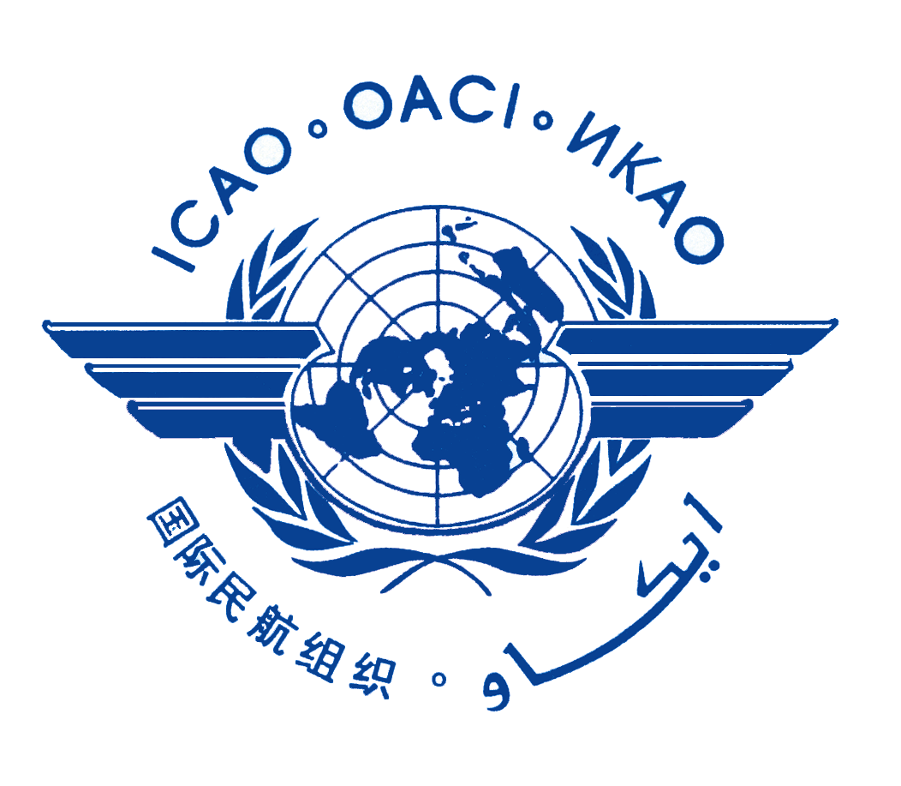
 | Continuing Airworthiness Programme
26th COSCAP-SA STEERING COMMITTEE MEETING

Phase IV Programme Progress Report
Discussion Paper 2 (DP-2)

(Presented by the CTA)

SUMMARY
The purpose of this paper is to outline the progress made to achieve programme objectives as stated in the COSCAP-SA Programme Document Phase IV and other additional objectives approved at the Steering Committee Meetings.

1. Background:

The Directors General of Civil Aviation of seven South Asian States, in association with ICAO, formed a Steering Committee to consider the possibility of participating in an ICAO Technical Cooperation Bureau proposed Programme for the cooperative development of operational safety and continuing airworthiness of aircraft in the Region. At its’ first meeting on 7-9 January 1997, the Steering Committee considered and approved the initial Project Document for the Cooperative Development of Operational Safety and Continuing Airworthiness Project – South Asia (COSCAP-SA).

The first Phase of the Project began implementation in 1997, with an initial duration of 5 years. The Project was revised in 2001 and its’ duration was extended to the end of 2007 (Phase II). At the 16th Meeting of the Programme Steering Committee, it was decided to extend into Phase III, covering the period from 2008 to 2012. During this phase, COSCAP-SA transferred into an institution to which Member States are committed through a Memorandum of Understanding (MOU). On 28 March 2012, the Steering Committee decided to extend the Programme by another five years, from 2013 to 2018 (Phase IV).

During each Phase, the Programme Steering Committee has reviewed and revised the Programme Objectives. Each year a Work Plan is developed to help the region achieve its’ goals.

2. Discussion of Immediate Objectives and Outputs:

The COSCAP-SA Steering Committee formally assigned priorities against the objectives and activities contained in Phase IV subsequent to the 23rd Steering Committee Meeting and determined that these be reviewed at each SC Meeting. The following criteria were utilized for assigning priorities:

- High- Work to achieve the objectives will be continuous.
- Medium- Work to achieve the objectives will be carried out as time permits.
- Low- little or no work will be carried out to achieve the objectives.

3. IMMEDIATE OBJECTIVES – Phase IV

3.1 Immediate Objective 1 – High Priority

The establishment of a dedicated forum/organization to facilitate dialogues and exchange of information and experience on aviation safety matters among COSCAP-SA Member States and promote solutions to common problems as well as provide a vehicle for the harmonization of policies, regulations and procedures related to aviation safety oversight.

Update: COSCAP-SA conducted regular meetings that provide the Member States with platforms that facilitate dialogues and exchange of information. State Visits, the Steering Committee, SARAST, APRAST, National Coordinators meetings and DGCA Conferences all focus on aviation matters. The CTA conducted the following activities to meet these objectives (Since July 2016):

STATE VISITS/MISSIONS within the following States:
- Bangladesh - October 2016 and 2017
- Bhutan – Home Base – multiple visits 2016-2017
- India – January, July and August/September 2017
- The Maldives - February and July 2017
- Sri Lanka - March 2017
- Nepal - October 2016 and November 2017
- Pakistan - January and May 2017

MEETINGS
- 25th SCM – July – 2016
- 53nd DGCA Conference – August – 2016
- COSCAP S SC Side Meeting – August – 2016
- 19th SARAST (teleconference) September – 2016
- 9th APRAST – November 2016
- 54th DGCA Conference – August 2017
- 9^{10h} National Coordinator – August 2017
- 19th SARAST (face to face) – August 2017
- 11th APRAST – November 2017
- 26th SCM – January 2018

3.2 Immediate Objective 2 - High Priority

Ensuring a coordinated, cost-effective approach for obtaining technical assistance in the field of aviation safety oversight, by minimizing duplication of efforts and allowing the sharing of available resources to the maximum extent. Promoting a comprehensive system approach/continuous monitoring approach for the conduct of safety oversight activities, focusing on effective implementation of Standards and Recommended Practices (SARPs), the efficient oversight capability of Member States and on assisting Member States in the effective implementation of the critical elements of safety oversight as identified by ICAO.

Update: Activities conducted by the CTA to meet this objective included the following:
Technical assistance/visit was provided to the following member States:
  - Sri Lanka (SACBM) – July 2016
  - Maldives (SACBM) – September 2016
  - COSCAP SA (Joint EASA Project) –September 2016
  - Nepal (SSC/2 Audits) – October 2016
  - Bhutan (PQ reviews) – November 2016
  - COSCAP SA (Joint EASA Project) – November 2016
  - Pakistan (SACBM) – December 2016
  - COSCAP SA (Joint EASA Project) – December 2016
  - India (SACBM) – January 2017
  - Bhutan (EASA RR Project) – February 2017
  - Bhutan – SACBM PEL – March 2017
  - Bhutan (EASA RR Project) – April 2017
  - Pakistan (TA) – May 2017
  - India (SACBM) – July 2017
  - Bangladesh (SACBM) – October 2017
  - Bhutan (SACBM) – October 2017
  - Nepal (SACBM) – November 2017

A partnership programme was established between the COSCAP SA and EU South Asia Project under the “COSCAP SA-EASA-SARI Joint activity plan (2017). In addition to training courses/OJT, COSCAP SA had also requested EASA to provide special assistance to Bhutan in regards to conducting a regulatory review. This would involve the introduction of SARI OPS/FCL albeit very customized for Bhutan’s operating environment. So far, three SARI workshops have been conducted.
Bangladesh will also be initiating a similar SARI OPS/FCL initiative to begin in February/March 2018.

A new COSCAP SA – EASA – SARI Joint Activity Plan is in the process of being developed for 2018. Course outlines and schedule should be made available in February 2018 after approval of the EC.

3.3 Immediate Objective 3- High Priority

Enhancing the knowledge and skills of the aviation safety professional personnel of COSCAP-SA Members, through a variety of formal training courses and on-the-job training.

Update: Activities conducted to meet this objective included the following:
- COSCAP SA Delivered/initiated Courses
- Joint APAC COSCAPs (COSCAP NA, SEA and SA) Courses
- EASA delivered courses (as per the joint activity plan 2017)
- SARI OPS/FCL Workshops

Courses/Workshops 2016-2017 (as of July 2016 to present) (DP4)

- August 15-19, 2016 Cabin Safety Course Bangkok (APAC COSCAPs)
- August 22-26, 2016 FOI Safety Oversight Course Bangkok (APAC COSCAPs)
- August 23-26, 2016 Basic SMS Course #1 (Joint CAA and Industry) Bhutan (30)
- October 3-7, 2016 Basic SMS Course #2 (Joint CAA and Industry) Bhutan (21)
- October 14-16, 2016 Executive SMS Part 1 and SACBM Project Bangladesh
- November 7-11, 2016 SSP Implementation Course Bangkok (APAC COSCAPs)
- December 23, 2016 Executive SMS Part 1 Bhutan (32)
- January 2-5, 2017 Basic SMS Course (Joint CAA and Industry) Pakistan
- January 16-18, 2017 Recurrent DG Training on ICAO Technical Instructions Bangkok (APAC COSCAPs)
- January 19-21, 2017 Recurrent DG Safety Oversight Workshop Bangkok (APAC COSCAPs)
- January 23-27, 2017 Basic SMS Course (CAA only) India (49)
- February 6-10, 2017 COSCAP SEA Audit Techniques and Practices for Regulators (each COSCAP SA States offered 2 seats)
- February 13-17, 2017 #1 SARI OPS workshop for update of regulations Bhutan
- February 20-24, 2017 COSCAP SEA AOC Surveillance for Airworthiness Inspectors (each COSCAP SA States offered 2 seats)
- February 27-28, 2017 Human factor workshop #1 (ATM) Maldives (11)
- March 1-2, 2017 Human factor workshop #2 (ATM) Maldives (12)
- March 6-7 Two Un-stabilized Approaches Prevention workshops by Airbus Maldives (65)
- March 7-10, 2017 #2 Basic SMS Course (CAA and Industry) Sri Lanka (28)
- March 13-17, 2017 COSCAP SEA Surveillance for Flight Operations (each COSCAP SA State offered 2 seats
- March 13, 2017 Executive SMS Course (Part I) Sri Lanka (8)
- March 14-17, 2017 #3 Basic SMS Course (CAA and Industry) Sri Lanka (23)
- April 17-27, 2017 #2 SARI OPS workshop for update of regulations Bhutan
- April 24-28, 2017 EASA - Combined FO Subjects (RVSM, AOC Cert, CAT II/III) Maldives
- May 08-12, 2017 EASA - SAFA and RAMP Inspection Training, Bangladesh
- May 10-23, 2017 EASA - OJT and implementation Training for Airworthiness Bhutan
- May 22-26. 2017 COSCAP SEA PEL Initial (each COSCAP SA State offered 2 seats)
- May 15-19, 2017 Audit Technique Course (Generic) Pakistan (53)
- May 23- June 1, 2017 EASA - SMS and SSP Implementation, including OJT in India
- May 24, 2017 Executive SMS Course (Part I) Pakistan (42)
- June 1-2, and 5 AIM Seminar Bangkok (APAC COSCAPs)
- June 5-15, 2017 EASA - FOI Initial Sri Lanka
- June 12-14, 2017 EASA - Operational Approvals - Airworthiness Inspections – India
- July 2-11, 2017 EASA – Airworthiness Inspector Initial – Maldives
- July 17-20, 2017 Basic SMS Course – Maldives
- July 17-28, 2017 EASA - Designated Medical Examiner – Bhutan
- July 26-28, 2017 EASA – Flight Simulator Evaluation – India
- July 30-Aug 8, 2017 EASA – Regultory Auditing Technicque (Airworthiness) – Bangladesh
- Aug 2-11, 2017 EASA – SMS&SSP Implementation – Sri Lanka
- Aug 14-23, 2017 EASA – Airworthiness Initial – Bangladesh
- Aug 28 – Sept 1, 2017 Audit Technique Course (OPS) – India
- Sept 4-7, 2017 EASA Human Factors – Maintenance – Bhutan
- Sept 5-7, 2017 EASA Operational Approvals AIR – Nepal
- Sept 11-15, 2017 EASA Regulatory Auditing Techniques (AIR) – India
- Sept 18-22, 2017 EASA SAFA and Ramp Inspection – India
- Sept 18- Oct 4, 2017 EASA OJT Instructor Training AIR (TT) – Sri Lanka
- Sept 18-26, 2017 EASA Combined FO Subjects – OPS – India
- Sept 25 – Oct 13, 2017 EASA OJT Instructor Training OPS (TT) – Sri Lanka
- Sept 26 – Oct 5, 2017 EASA SMS/SSP Implementation Training – Bhutan
- Sept 26 – Oct 5, 2017 #3 SARI OPS/FCL workshop – Bhutan
- Oct 09-13, 2017 EASA Regulatory Auditing Techniques (AIR) - Nepal
- Oct 22-31, 2017 EASA SMS/SSP Implementation Training – Bangladesh
- Oct 30- Nov 11, 2017 Combined FO Subjects – Nepal
- Nov 13-17, 2017 Aerodrome Certification Course (ACI) – Pakistan
- Nov 6-17, 2017 EASA Cabin Crew Initial – Bangladesh
- Nov 20-28, 2017 EASA Continuing Airworthiness - Sri Lanka
- Dec 4-8, 2017 Designated Check Pilot Course Initial – Bhutan
- Dec 11-13, 2017 EASA Reliability Programmes – Sri Lanka

3.4 Immediate Objective 4 – High Priority
Using Programme Personnel, personnel seconded from other COSCAP-SA Members or ICAO Staff, undertake missions to COSCAP-SA Member States to maintain liaison and augment the resources of those Member administrations.

Update: Activities conducted to meet this objective included the following (DP6):

- The South Asia Capacity Building Matrix (SACBM) was developed to identify inspectors/officers within South Asia Member States - Civil Aviation Authorities/DGCAs who could provide support in terms of expertise/training and technical assistance to other Member States within the sub region (South Asia). In addition, the SACBM also identifies retired inspectors/officers who could continue to provide support to member States (COSCAP SA would employ them). Note: At a later stage, it is also intended to include South Asian experts within the industry on the SACBM.
- The SACBM Phase One and two are now complete keeping in mind that the matrix is a “living document” which will continue to grow, change and evolve with time. A draft procedures manual has been developed for approval of the SCM. The SACBM will be computerized in the spring of 2018 and will be posted on the new COSCAP SA website. Access to the Website COSCAP SA - SACBM will be made available to Member States albeit restricted. Note: The information within the SACBM is protected.
- The SACBM is now fully operational. Member States may request assistance through the CTA accordingly.

3.5 Immediate Objective 5 – Medium Priority

Assisting within available resources COSCAP-SA Member States in rectifying deficiencies identified by USOAP audits on aspects covered by Annexes 1, 6, 8, 10, 11, 13 and 14. Support Member States in implementation of CMA Processes and States who may be audited under the CMA.

Update: Activities conducted to meet this objective included the following (DP4):

- The CTA provided support to Nepal in regards to OPS and PEL related PQs. The establishment of Regulatory Compliance Implementation Audit (RCIA) was initiated for three international operators to determine level of compliance and level of implementation of CAAN aviation legislation including regulations and requirements. This directly tied in with the resolution of related OPS PQs in preparation of the ICAO ICVM in July 2017 (focused to remove SSC).
- The CTA provided support and technical advise to Bhutan in regards to PQs associated with OPS and PEL areas. Key areas have been identified to enable Bhutan to address their PQs.
- In relation to the above, the CTA arranged with EASA a Regulatory Review Project in order to update the Bhutan Civil Aviation Regulations and requirements. This in turn will enable Bhutan to update their guidance material in regards to the regulation followed by an update on their inspector Guidance manuals. This in turn will enable Bhutan CAA to address many PQs that are rooted into the above developments/updates
- The CTA has also arranged an Airworthiness OJT/Workshop with EASA for Bhutan in order to address training and related PQs
- The CTA is recruiting an International ANS expert to provide support to Bhutan in order to address the outstanding PQs. In addition, the CTA has also requested EASA to provide Technical Support to Bhutan to assist in addressing the Aerodrome issues/PQs. It is expected that the two experts will on duty in April 2018.

3.6 Immediate Objective 6 – High Priority

Supporting Member States to establish an effective Safety Management Systems in the area of Aircraft Operations, Aerodromes and Air Traffic Management.

Update: Activities conducted to meet this objective included the following (DP4):

The following training was provided to Member States in order to assist in establishing an effective SMS among their operators:
- Basic SMS courses to Bhutan, India, Bangladesh, Sri Lanka, Pakistan and Maldives
- Executive SMS Part I courses to Bhutan, Bangladesh, Sri Lanka, and Pakistan
- EASA SMS and SSP Implementation Training including OJT for Bhutan, Bangladesh, Sri Lanka, and India
- Executive SMS Part II and III courses have been scheduled for February 2018. The course will be co-presented by Dr. Li from China (specialist in SMS/SSP SPI/SPT) and the CTA COSCAP SA

3.7 Immediate Objective 7 – High Priority

Supporting Member States in establishing an integrated State Safety Programme by identifying the gaps in States SSP and develop an action plan to address the gaps.

Update: Activities conducted to meet this objective included the following:

- An SSP course was delivered in Bangkok in November 2016 for all Member States to participate.
- EASA SMS and SSP Implementation Training was delivered to Bhutan, Bangladesh, Sri Lanka and India
- Further training in SSP is planned for 2018

3.8 Immediate Objective 8 – Medium Priority

Supporting the Member States in the effective implementation of Performance Based Navigation (PBN) in coordination with ICAO RO and the ICAO Flight Procedures Programme (FPP).

Update: Activities conducted to meet this objective included the following:
- The CTA continues to support Member States in the effective implementation of PBN related activities on a demand basis.
- Bhutan CAA has requested the CTA to provide support and technical assistance in the operational approval of a new RNP AR – Paro approach. The CTA attended meetings with RNP AR designers (Nav Blue) and participated in RNP AR simulator demonstrations (Nav Blue and Airbus) in Bangkok with BCAA, Designers, Airbus and their operators. The CTA will continue to provide operational support for the final operational evaluation phase accordingly.

4 Action of the Meeting

4.1 The Steering Committee is invited to:

- Comment on the nature of the work completed; and
- Confirm or revise programme priorities.

